بسم الله الرحمن الرحيم

ِAlgorithm Project
Name: Fakher Talahmeh
n | N log n | Selection | Bubble | Insertion | Merge | Quick
100 | 0.0002 | 0.0007 | 0.00008 | 0.00006 | 0.0010 | 0.00005
500 | 0.0015 | 0.0080 | 0.0069 | 0.0119 | 0.00008 | 0.0029
1000 | 0.003 | 0.04888 | 0.04387 | 0.06378 | 0.00299 | 0.01196
2000 | 0.007 | 0.15658 | 0.2164 | 0.2473 | 0.0029 | 0.0109
3000 | 0.0186 | 0.8687 | 1.0512 | 1.503 | 0.0139 | 0.0489
4000 | 0.01566 | 1.4822 | 2.0407 | 2.6190 | 0.01695 | 0.0608
5000 | 0.0252 | 2.4676 | 3.0278 | 4.0875 | 0.0259 | 0.0667
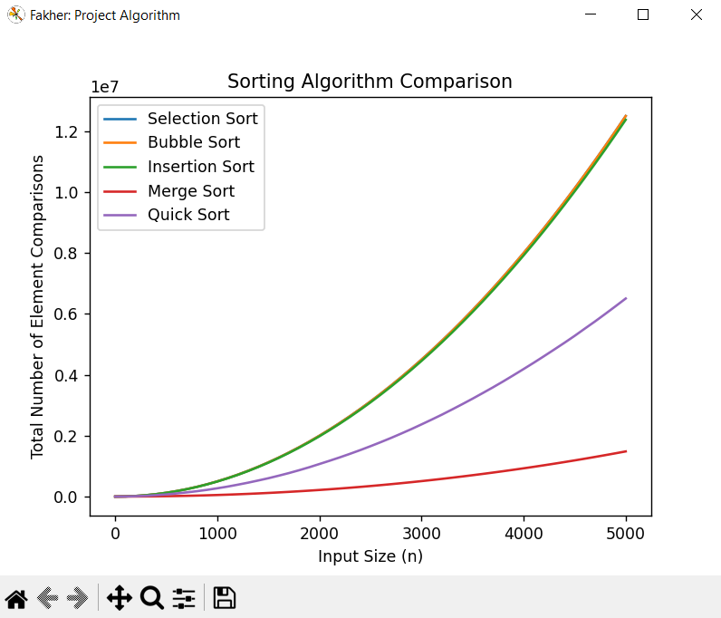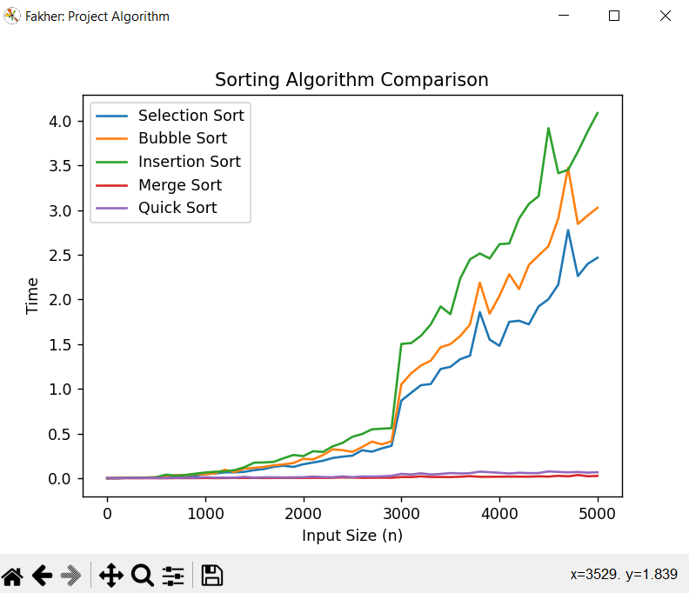

import random
import time
import matplotlib.pyplot as plt
import quicksort
import mergesort
import selectionsort
import bubblesort
import insertionsort

selection_comparisons = []
bubble_comparisons = []
insertion_comparisons = []
merge_comparisons = []
quick_comparisons = []
quicktime = []
selectiontime = []
mergetime = []
insertiontime = []
bubbletime = []
# Generate the input values and sort using different algorithms
for n in range(0, 5001, 100):
input_arr = [random.randint(0, 100) for i in range(n)]

quicksort.i = n
# Selection Sort
start_time = time.time()
selection_comps = selectionsort.selection_sort(input_arr)
end_time = time.time()
selection_time = end_time - start_time
selectiontime.append(selection_time)
selection_comparisons.append(selection_comps)

# Bubble Sort
start_time = time.time()
bubble_comps = bubblesort.bubble_sort(input_arr)
end_time = time.time()
bubble_time = end_time - start_time
bubbletime.append(bubble_time)
bubble_comparisons.append(bubble_comps)

# Insertion Sort
start_time = time.time()
insertion_comps = insertionsort.insertion_sort(input_arr)
end_time = time.time()
insertion_time = end_time - start_time
insertiontime.append(insertion_time)
insertion_comparisons.append(insertion_comps)

# Merge Sort
start_time = time.time()
merge_comps = mergesort.mergesort_with_count(input_arr)
end_time = time.time()
merge_time = end_time - start_time
mergetime.append(merge_time)
merge_comparisons.append(mergesort.comparisons[0])

# Quick Sort
start_time = time.time()
quick_comps = quicksort.quicksort_with_count(input_arr)
end_time = time.time()
quick_time = end_time - start_time
quicktime.append(quick_time)
quick_comparisons.append(quicksort.comparisons[0])

print(f"n = {n}, Selection Comparisons = {selection_comps},Time ={selection_time} | Bubble Comparisons = {bubble_comps},Time ={bubble_time} | "
f"Insertion Comparisons = {insertion_comps},Time ={insertion_time} | Merge Comparisons = {mergesort.comparisons[0]},Time ={merge_time} | "
f"Quick Comparisons = {quicksort.comparisons[0]},Time ={quick_time} ")

# Plot the results
n_values = [i for i in range(0, 5001, 100)]
plt.figure("Fakher: Project Algorithm")
plt.plot(n_values, selection_comparisons, label='Selection Sort')
plt.plot(n_values, bubble_comparisons, label='Bubble Sort')
plt.plot(n_values, insertion_comparisons, label='Insertion Sort')
plt.plot(n_values, merge_comparisons, label='Merge Sort')
plt.plot(n_values, quick_comparisons, label='Quick Sort')
plt.xlabel('Input Size (n)')
plt.ylabel('Total Number of Element Comparisons')
plt.title('Sorting Algorithm Comparison')
plt.legend()
plt.show()
plt.figure("Fakher: Project Algorithm")
plt.plot(n_values, selectiontime, label='Selection Sort')
plt.plot(n_values, bubbletime, label='Bubble Sort')
plt.plot(n_values, insertiontime, label='Insertion Sort')
plt.plot(n_values, mergetime, label='Merge Sort')
plt.plot(n_values, quicktime, label='Quick Sort')
plt.xlabel('Input Size (n)')
plt.ylabel('Time')
plt.title('Sorting Algorithm Comparison')
plt.legend()
plt.show()

Bubble Sort
import random

def bubble_sort(arr):
n = len(arr)
comparisons = 0
for i in range(n):
for j in range(n-i-1):
if arr[j] > arr[j+1]:
arr[j], arr[j+1] = arr[j+1], arr[j]
comparisons += 1
return comparisons
i=0
arr = random.sample(range(1, i+1), i)
comparisons = bubble_sort(arr)

Insertion sort
import random

def insertion_sort(arr):
comparisons = 0
for i in range(1, len(arr)):
key = arr[i]
j = i - 1
while j >= 0 and key > arr[j]:
arr[j+1] = arr[j]
j -= 1
comparisons += 1
arr[j+1] = key
return comparisons
i=0
arr = random.sample(range(1, i+1), i)

Merge Sort
import random

def merge(left, right):
result = []
i = j = 0
while i < len(left) and j < len(right):
if left[i] < right[j]:
result.append(left[i])
i += 1
else:
result.append(right[j])
j += 1
result += left[i:]
result += right[j:]
return result

def mergesort(arr):
if len(arr) <= 1:
return arr
mid = len(arr) // 2
left = mergesort(arr[:mid])
right = mergesort(arr[mid:])
return merge(left, right)
i = 0
arr = random.sample(range(1, i+1), i)
comparisons = [0] # to keep track of number of comparisons made

def mergesort_with_count(arr):
if len(arr) <= 1:
return arr
mid = len(arr) // 2
left = mergesort_with_count(arr[:mid])
right = mergesort_with_count(arr[mid:])
merged = merge(left, right)
comparisons[0] += len(merged)
return merged

sorted_arr = mergesort_with_count(arr)

Quick Sort
import random

def quicksort(arr):
if len(arr) <= 1:
return arr
else:
pivot = arr[0]
less = []
equal = []
greater = []
for x in arr:
if x < pivot:
less.append(x)
elif x == pivot:
equal.append(x)
else:
greater.append(x)
return quicksort(less) + equal + quicksort(greater)
i=0
arr = random.sample(range(1, i+1), i)
comparisons = [0] # to keep track of number of comparisons made
def quicksort_with_count(arr):
if len(arr) <= 1:
return arr
else:
pivot = arr[0]
less = []
equal = []
greater = []
for x in arr:
comparisons[0] += 1
if x < pivot:
less.append(x)
elif x == pivot:
equal.append(x)
else:
greater.append(x)
return quicksort_with_count(less) + equal + quicksort_with_count(greater)

sorted_arr = quicksort_with_count(arr)

Selection Sort
import random

def selection_sort(arr):
comparisons = 0
for i in range(len(arr)):
min_idx = i
for j in range(i+1, len(arr)):
if arr[j] < arr[min_idx]:
min_idx = j
comparisons += 1
arr[i], arr[min_idx] = arr[min_idx], arr[i]
return comparisons
i=0
arr = random.sample(range(1, i+1), i)
comparisons = selection_sort(arr)

